**PROJECT MID-TERM REPORT**

**On**

**“Parking Management System”**



<College logo>

**SUBMITED TO:- SUBMIT BY:-**

<lecture name> <student name>

CLASS ROLLNO

<Branch>

**DECLARATION**

I hereby declare that the Industrial Training Report entitled ("Title of the project") is an authentic record of my own work as requirements of 6-months Industrial Training during the period from _______ to_______ for the award of degree of B.Tech.(Information Technology, **college name** under the guidance of (Name of Project Guide).

**(Signature of student)**

**(Name of Student)**

**(University Roll No.)**

**Date: ____________________**

Certified that the above statement made by the student is correct to the best of our knowledge and belief.

**Head of Department**

**(Signature and Seal**

**COMPANY PROFILE**

INFOWIZ is leading strategic IT Company offering integrated IT solution. INFOWIZ is having rich experience managing global clients across various business verticals and align IT strategies to achieve business goals. The various accreditations that we achieved for every service, we offer reflect our commitment towards the quality assurance.

**INFOWIZ** is a 8 yearsyoung organization which has won the **NATIONAL AWARD** for **2 consecutive years 2014-2015 & 2015-16** for **BEST Industrial Training** from **Hon` able** **GOVERNER of Punjab & Haryana Sh. Kaptan Singh Solanki.** He is also the **Chancellor of PTU & Punjabi University**. INFOWIZ is a member of Confederation of Indian Industry ( **CII membership number – N4654P** ) & also withan **ISO Certification**. We have a global foot prints in providing the off shore companies of US, UK, France, Ireland, Canada and Australia with quality and timely Web and SEO services.

INFOWIZ is an organization which is established in the field of Web Development (PHP & .NET), JAVA (Core as well as Advance), I-phone & Android Applications, Embedded systems (AVR, PIC & ARM),Automation, ROBOTICS, Networking (MCSE, CCNA & RHSE) & in Mechanical.

Our skilled team of professionals make sure that the product is developed as per the customer’s needs and keeping the customer informed about the development of their project from time to time. We do not only emphasize on formulating an attractive solution to our clients but also believe in providing a workable solution. INFOWIZ offers research based Search Engine Marketing products that help achieve greater insights to customer’s online business. Our Research & Development arm offers SEO tools for SEM professionals.

INFOWIZ also provides **Technical Support & Consultancy** to Software Companies like JIA Group, Newzealand, Sagitech solutions Panchkula, Jarc infotech Mohali, Infonet Solution, Delhi etc.

**Our Hottest Clients & Projects:-**

**PROJECTS URL’s COUNTRY**

1. Viva Sales www.[**infowiz.in/vivasales**](http://infowiz.in/vivasales) UK
2. Mds Creative www.mdscreative.com Germany
3. Liddle TV www.filmon.com UK
4. Paradigms( Android) running Australia
5. Printcost www.popgraphics.net UK
6. PSTDO Bootstrap www.bootstrap.achieversperfect.com USA
7. Essencesoftwares www.essencesoftwares.com Australia
8. Dashboard(Wordpress) running USA

9) Realstate www.realestate.infowiz.in Russia

10) Dealpartners(WordPress) www.dealpartners.co.uk.gridhosted.co.uk UK

11) Littletonvineyard www.littletonvineyard.net USA  
 12) Gpakoffshore www.gpakoffshore.com UK

**OUR TEAM:-**

**“A Ship is as good as the crew who sail her**.**”**

Our Technical team of professionals handing, designing & delivering of projects has a strong presence in the North India & the US. Our engineers are already working on the latest technologies like **I-Phone & Android** Applications, **Robotics**, **VLSI-VHDL**, Embedded System, Networking and **Cloud computing.**

1) Dr. Seema

(**Managing Director**)

She is the backbone of INFOWIZ and a woman with more than 9 year rich practical experience

who believes in taking up new ventures and projects.

2) Mr. Rajeev Nayyar

(**Deputy Director**)

A man who strongly feel that “Nothing is Impossible”. A very committed team leader who has

been professionally attached with Multinational companies for more than 18 years and has lead

the marketing teams in all states of North India.

3) Mr. Deepak Kasyap

**(Branch Manager)**

A man who believes that “Honour Time & Place, then you will be honoured.” he has more

than 4 years solid industrial experience in a software companies & is very dashing and innovative

in his technical approach.

4) Ms. Urvashi

**(Dean Academics)**

A woman who believes that “Challenges are what make life interesting and overcoming them is

what makes life meaningful.” She has more than 3years experience in business development.

5) Ms. Amita

**(Manager)**

A woman believes that “don’t wait for extra ordinary opportunities, seize common occasions and

make them great.” She has more than 4 years experience in marketing field.

6) Er. Vishal Goyal

(**Head & Technical Advisor at US Branch**)

More than 10 years industrial experience in US and smooth handling of the entire US business.

7) Er. Yukti Jindal

(**Center Head- US Branch**)

A woman who firmly believes that “In life, where you reach largely depends upon where you

start.” She joined this branch in the year 2007 and has given her immense inputs in bringing the

company to its present status.

**COURSES Offered :-**

**For CSE/IT/MCA Professionals:-**

1. Web Development in PHP with LIVE Projects
2. Web Development in .NET with LIVE Projects
3. JAVA (Core as well as Advance ) with LIVE Projects
4. Android Applications with LIVE Projects
5. Web Designing (Photoshop, Coral Draw)
6. C#, Console Applications, VB.NET, ASP.NET
7. MySQL, SQL, ORACLE
8. Networking (MCSE, CCNA, RHSE)
9. SEO (Search Engine Optimization)

**For ECE/EE/EIE/ME/CIVIL Professionals:-**

1. Robotics With Live Project
2. VLSI-VHDL with Live Project
3. Embedded System Design with Live Project
4. Microcontroller with Live Project
5. Microprocessor with Live Project
6. PCB Designing
7. AVR & PIC Family
8. PCB and layout designing
9. AUTOMATION with Live Project
10. Project development with ARM processors
11. CATIA, PRO-E, AUTOCAD, SOLID WORKS.

Our core strength is our timely, technically and cost effective project delivery. We also provide customers with designs as per their demands. INFOWIZ also provide **JOB Oriented Industrial**.

**PROJECT OVERVIEW**

**INTRODUCTION**

In the modern world, where parking-space has become a very big problem and in the era of miniaturization, it is become a very crucial necessity to avoid the wastage of space in modern, big companies and apartments etc. In places where more than 100 cars need to be parked, this system proves to be useful in reducing wastage of space. This Automatic Multi-Level Car Parking System enables the parking of vehicles, floor after floor and thus reducing the space used. Here any number of cars can be parked according to the requirement. This makes the system modernized and even a space-saving one.

Automatic Multi-Level Car Parking System provides an automatic parking mechanism which works as follow -

When any vehicle enters the parking facility it gets detected using some Infra-red sensors and gate is opened for vehicle entry and Vehicle Counter is incremented.

One Bi-Color Led which blinks Red if lift is busy or Green if lift is free and on ground floor ready to serve the next vehicle. Lift is equiped with multiple sensors for automatic operations and one button for returning condition.

On Green Signal vehicle must moved into the lift. When Lift detects the vechile placed in proper orientation, it starts moving and stops on the floor where slots for parking is available. Space Availablity on a particular floor is maintained on sensor basis. After the parking is done user has to  press a button on lift to come back down on ground floor.

Signal for a particular event is indicated timely by some Leds and a beeper. Parking System also include a LCD to display Important messages to user.

**Features**

* Car Counting System using Infra-Red Sensors.
* Automatic Door Opening using IR Sensors.
* Sensor based Lift System for moving vehicle to the right floor.
* Easy to use System.
* Multiple Floor to reduce space.

**DISADVANTAGES OF CAR PARKING:-**

* Drivers who use multi parking facilities, sometimes known as parking garages, often enjoy a number of benefits the structures provide. Despite the ability of the garages to house a large number of cars, multi-story parking facilities also carry a number of distinct disadvantages that arise from their tall, enclosed and often dimly lit nature
* **1.Deterioration and Maintenance**
* Multi-story parking facilities support hundreds of thousands of pounds of vehicles, people and equipment every day. Because the garages support very large amounts of weight and loads that constantly change, the structures quickly deteriorate in the absence of constant maintenance activity. In addition, according to Canada’s National Resource Council, changing weather and environmental conditions can deteriorate a garage’s steel support structure, creating an unsafe environment for garage users. A number of corrosion inhibitors can help delay processes that eat away at the structure’s integrity, according to the National Resource Council, but constant maintenance and upkeep must include anti-corrosion measures to keep multi-story parking facilities structurally sound.

**2.Parking Angle Considerations**

Because many drivers of varying levels of skills and experience drive in, around and out of parking garages every day, designers must pay special attention to the configuration of parking spaces within the structures. In a municipal parking garage presentation prepared by architects Sakri and Khairuddin, the designers noted that two-way traffic flow in a multi-story garage presents a number of parking challenges for drivers and designers. Parallel parking, for example, creates an inefficient use of limited space, while straight parking spaces make parking difficult for some drivers. Other options, like angled parking, do not work well with a two-way traffic flow and can only work well in garages with separate entrance and exit openings.

**3.Lighting**

While most parking lots open at night, multi-story or otherwise, require some form of lighting, the multi-story nature of parking garages creates a need for numerous lights throughout the structure. In addition, because the inside of the structure may remain dark even during the day, many of these lights must run at all times. This arrangement can create high energy bills for garage owners and may require frequent lighting maintenance to replace broken or burned-out bulbs

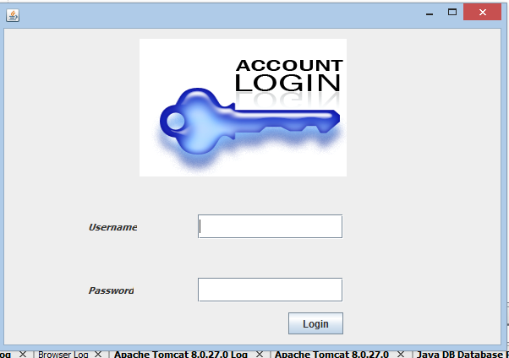



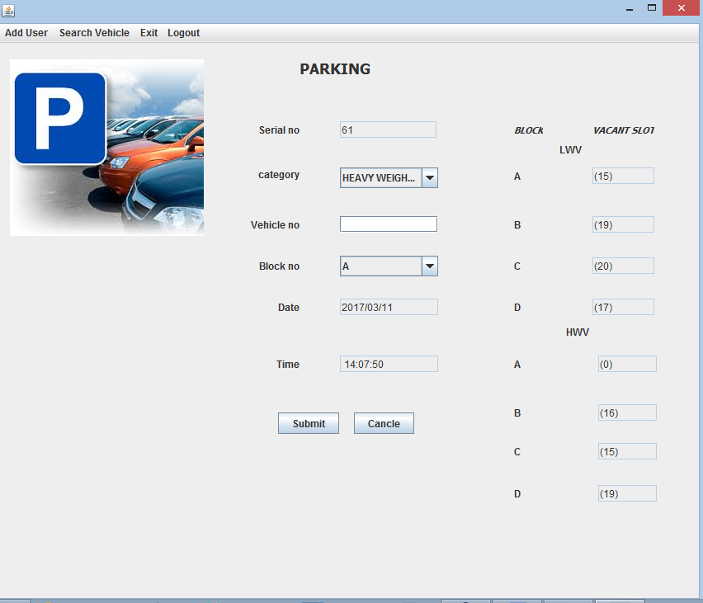

**Parking** is the act of stopping and disengaging a [vehicle](https://en.wikipedia.org/wiki/Vehicle) and leaving it unoccupied. Parking on one or both sides of a road is often permitted, though sometimes with restrictions. Some buildings have parking facilities for use of the buildings' users. Countries and local governments have rules for design and use of [parking spaces](https://en.wikipedia.org/wiki/Parking_space).

A **car parking system** is a mechanical device that multiplies parking capacity inside a [parking lot](https://en.wikipedia.org/wiki/Parking_lot). Parking systems are generally powered by [electric motors](https://en.wikipedia.org/wiki/Electric_motors) or [hydraulic pumps](https://en.wikipedia.org/wiki/Hydraulic_pump) that move vehicles into a storage position.

There are two types of car parking systems: traditional and automated. In the long term, automated car parking systems are likely to be more cost effective when compared to traditional parking garages. Automatic multi-storey automated car park systems are less expensive per parking slot, since they tend to require less building volume and less [ground area](https://en.wikipedia.org/w/index.php?title=Ground_area&action=edit&redlink=1) than a conventional facility with the same capacity. Both automated car parking systems and automated parking garage systems reduce [pollution](https://en.wikipedia.org/wiki/Pollution) — cars are not running or circling around while drivers look for parking spaces